

# Team 24 – Sprint 1 Testing Document

Sakshi Choudhary, Giorgi Khmaladze, Nick Litman, Mihir Somani, Conley Utz

# User Story #03

**Test 1: Testing if a user can sign out.**

Purpose: To meet the acceptance criteria, user should be able to sign out from their account from any page and once they press logout it should display a logout success message and redirect the user to sign in page. Also, user can’t access any other page once they are signed out.

Steps:

1. The user is able to sign out from all the pages.

account.php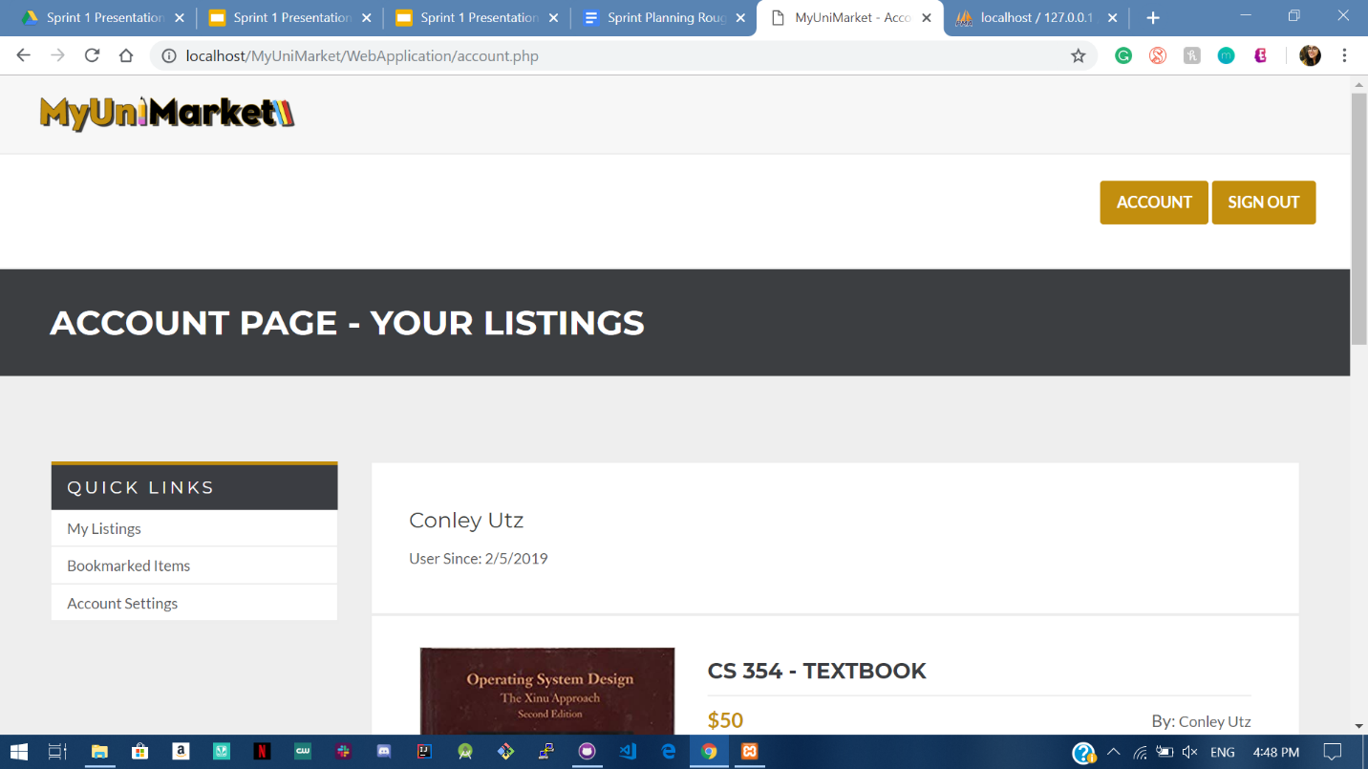

account2.php

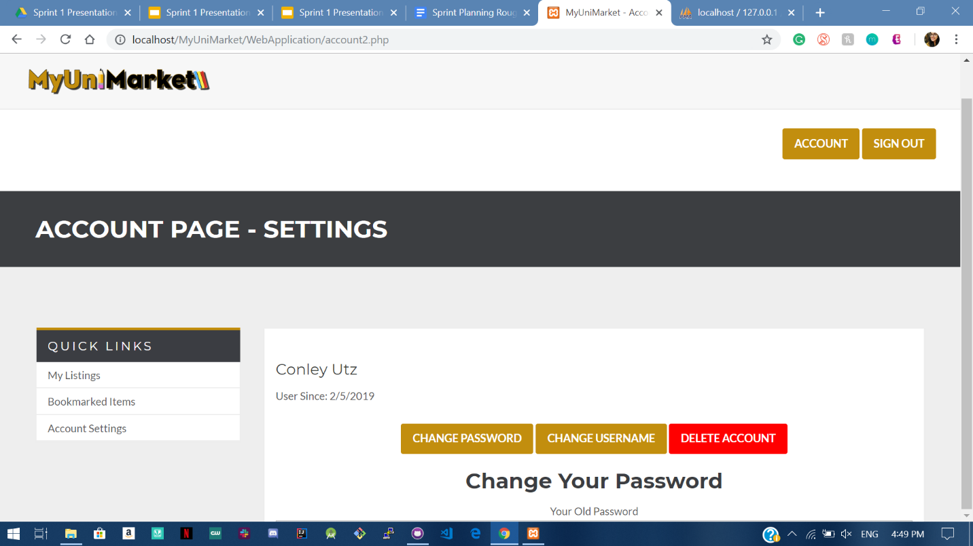

create.php 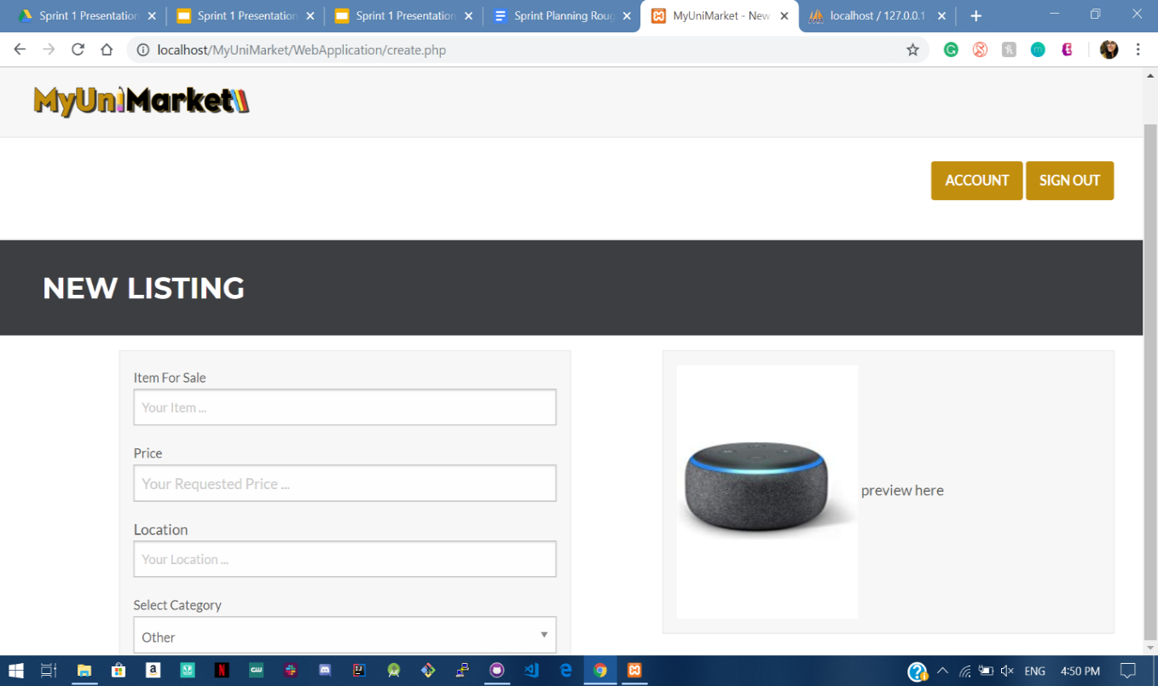

market.php

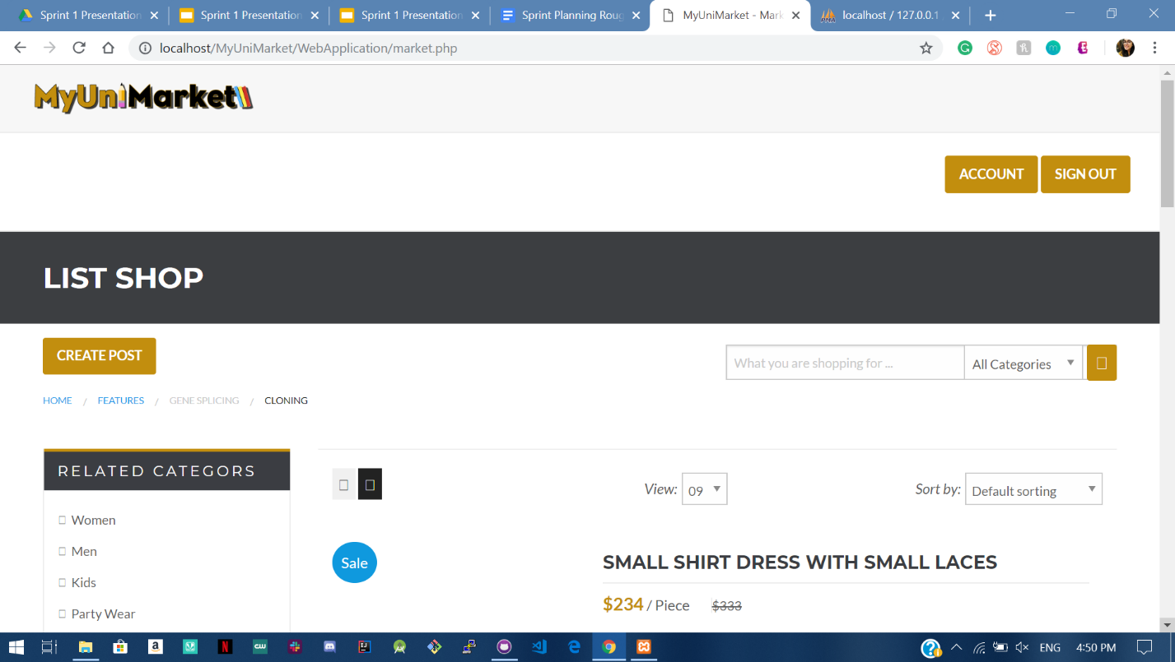

1. The user clicks sign out and SUCCESS message pops up

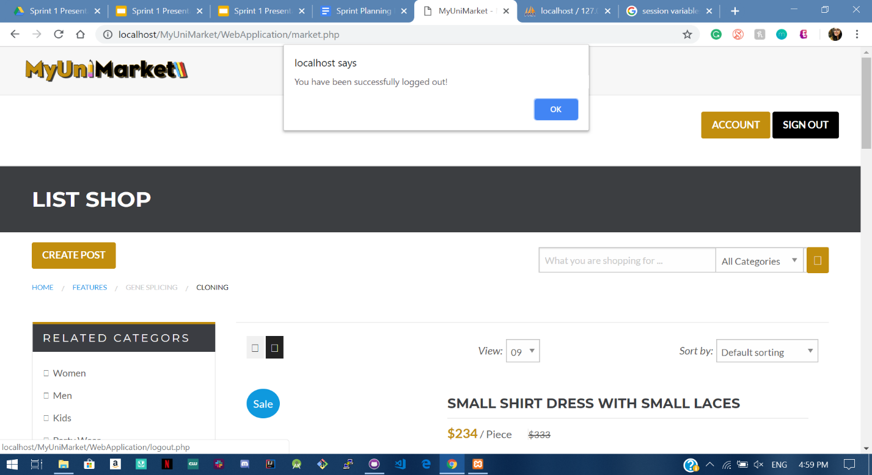

1. The User is redirected to sign in when they press OK.

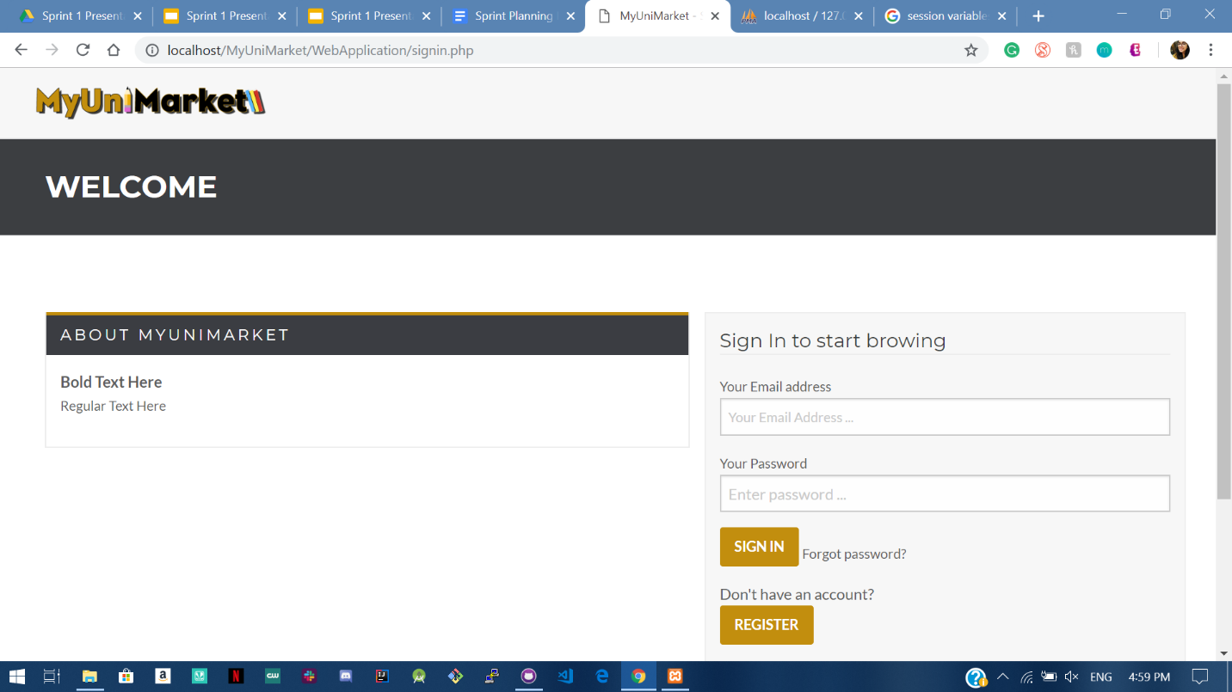

1. The session variables are modified once the user signs out, so that they can’t access any page without signing in (they are redirected to signin.php).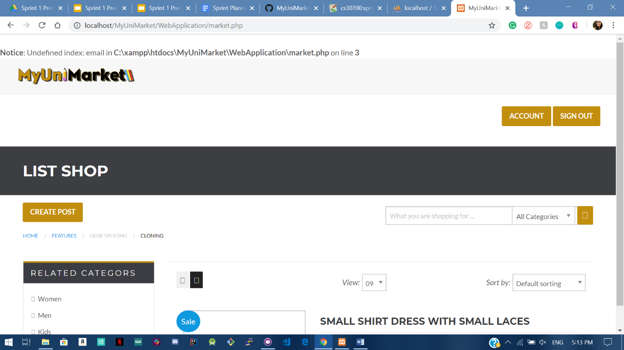

Expected Result: User is successfully able to sign out.

Test Result: **PASSED**